**DAILY ONLINE ACTIVITIES SUMMARY**

|  |  |  |  |  |  |  |  |  |
| --- | --- | --- | --- | --- | --- | --- | --- | --- |
| **Date:** | **20-06-2020** | | | | | **Name:** | **Kanaka BS** | |
| **Sem & Sec** | **6th & A** | | | | | **USN:** | **4al17cs039** | |
| **Online Test Summary** | | | | | | | | |
| **Subject** | |  | | | | | | |
| **Max. Marks** | |  | | **Score** | | |  | |
| **Pre-placement Training Summary** | | | | | | | | |
| **Course** | **Programming in C++** | | | | | | | |
| **Certificate Provider** | | | Ms.ANKITHA SHETTY  Mr. Pradeep Nayak | | **Duration** | | | **3hours** |
| **Coding Challenges** | | | | | | | | |
| **Problem Statement:** 2 Programs | | | | | | | | |
| **Status: Solved** | | | | | | | | |
| **Uploaded the report in Github** | | | | | **yes** | | | |
| **If yes Repository name** | | | | | **Online Coding Repository**  <https://github.com/kanakabs/Daily-Status/tree/master/20-06-20> | | | |
| **Uploaded the report in slack** | | | | | **yes** | | | |

**SNAPSHOTS**

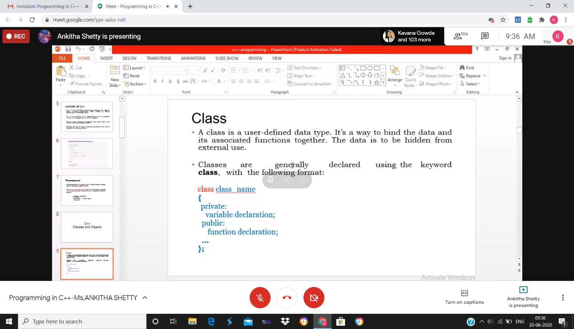

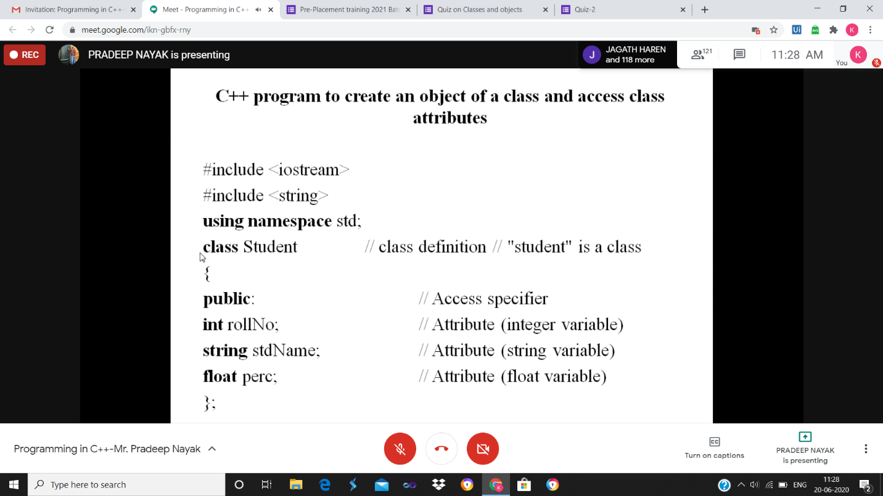

ONLINE CODING

<https://github.com/kanakabs/Daily-Status/tree/master/20-06-20/online%20coding>